QUICK INFORMATION FORM

Photograph


- First Name: Vinay kumar

- Middle Name:

- Last Name: R

Xoriant Email Format: First Name.Last Name@Xoriant.com e.g. Ajay.Singh@Xoriant.com

- Your preferred Xoriant Email id: Vinay.r@xoriant.com
- Mobile Number: 7795132551 5. Landline Number:

- Emergency Contact Information:

Name: Sathyabhama
Mobile Number: 6363513543

Relationship with employee: Mother

- Permanent Address: Hospete road, Rayappana galli, 5th ward, Magadi, 562120
- Temporary/ Local Address: Indraneelam, Munneshwara Layout, Thubarahalli, Munnekollal, Bangalore, 560037
- Blood Group:B+

- Date of Birth: (DD/MM/YYYY) – 12/09/1998

- Pan Card No. : DSEPR7565A

- Religion : Hindu (Optional)
Y
- Marital Status : Married Unmarried

NOMINATION FORM

Employee Name: Vinay kumar R

Employee No.: 7795132551

I declare the person mentioned below as my nominee to receive any legal dues towards me from the Xoriant Solutions Pvt. Ltd., in the event of my death or termination of services with the organization due to mental disorder / disability.

Name of the Nominee: Sathyabhama

Relation with employee: Mother

Date of Birth: 01/01/1968

Age: 58 Years *

Address of the Nominee: Hospete road, Rayappana galli, 5th ward, Magadi, 562120

- If the nominee is minor, I appoint Mr. / Ms.Sathyabhama Age: 58
,Address: Hospete road, Rayappana galli, 5th ward, Magadi, 562120

to receive such dues on behalf of my nominee as mentioned above.

Any such due amount paid by Xoriant Solutions Pvt. Ltd. to the nominee will be deemed as the full discharge of the liability.

This nomination does not have relation with my Provident / Pension Fund account nomination, as I have already declared nominee in the PF forms while joining the company.

Scanned Signature of the Employee: 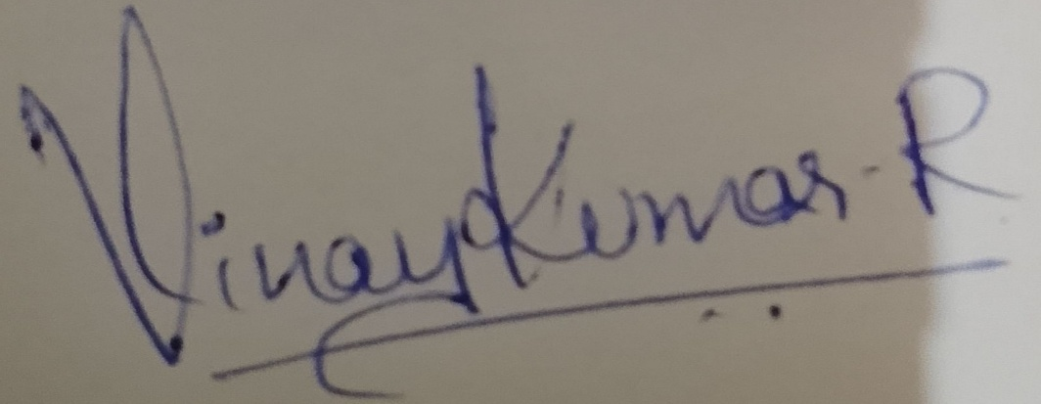

Name: Vinay kumar R

Date: 12/09/1998

Place: Magadi

LIST OF DOCUMENTS

(Create a zip folder with all the below documents & send as a attachment)

Employee Name:

- 1 passport size photograph

- Education:

• SSC & HSC Mark sheets

• Mark sheets (All Semesters) and convocation certificates of degree/ post graduation.

- Additional Education Certificate and Make sheets if any (Eg. Diploma, NIIT, NCSt, MCSD, Novell Netware etc.)

- Employment:

- Appointment letter, Experience and relieving certificates from ex- employer and last 2

month’s pay slip.

- Previous all ex-employer’s appointment letters, experience and relieving certificates and

last month’s pay slip.

- Passport:

• All relevant pages. Include if any previous visa / Work Permit authorization and other documents.

5) Marriage certificate

- Pan Card &

- Residential Proof (Lightbill/Rent Agreement)

- Aadhar Card

Please mention the reason, if any of the above documents are not given/ mailed.
Not included Marriage certificate as I am Unmarried.

I hereby accept that all the above documents have been collected with my consent.

Documents checked by: ____________ Date of Joining : 12/06/2026

HR Signature: ____________ Scanned Employee Signature: ____________
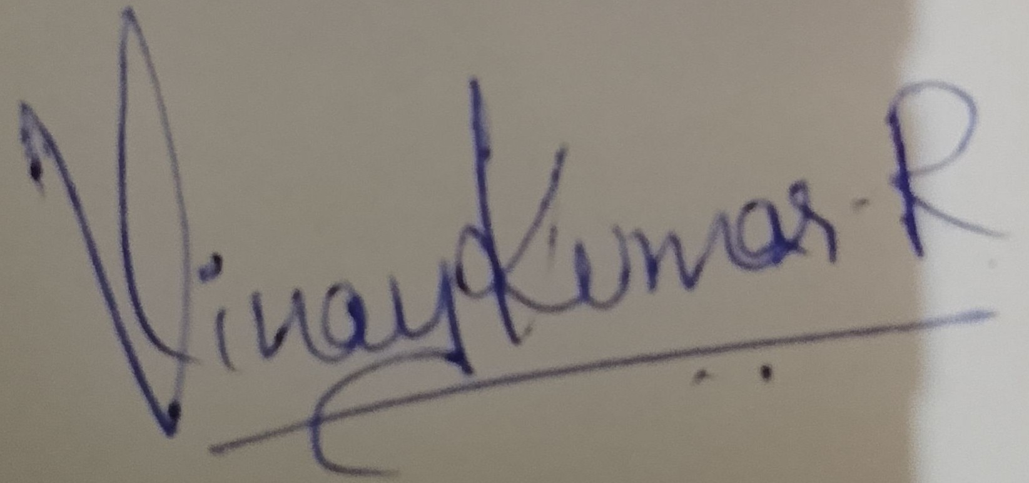
Note: One Independent set of photocopies to be submitted for all above documents

EMPLOYEE ID CARD



Employee Name | : - | _______________________________________________
Employee Code | : - | _______________________________________________
Branch Name | : - | __Baner Pune_____________________________
Designation | : - | ____________________________________________
D.O.J. | : - | ____________________________________________
Contact No. | : - | ____________________________________________
Emergency Contact No.: - ____________________________________________
Blood Group | : - | ________________________________________________

